RESIDENTIAL LEASE AGREEMENT

1. THE PARTIES. This Residential Lease Agreement (“Agreement”) is made on February 04, 2025 by and between:

Landlord  
Name: Manuel Murphy  
Mailing Address: 51731 Graves Mountains, New Jennifer, MI 43162

Tenant  
Name: John English  
Mailing Address: 3917 Joseph Points Suite 667, East Jessica, FM 47417

2. PROPERTY  
Property Address: 180 Davis Lights Apt. 986, New Aaronburgh, CO 71841  
Residence Type: House  
Bedroom(s): 4 Bathroom(s): 3

3. TERM  
Start Date: March 05, 2025  
End Date: August 28, 2026

4. RENT  
Monthly Rent: $1898  
Due Date: 1st day of each month.

5. SECURITY DEPOSIT  
Amount: $4386

IN WITNESS WHEREOF, the Parties have executed this Agreement as of the date first above written.

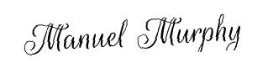

Landlord's Signature: __________________________

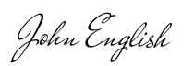

Tenant's Signature: __________________________