RESIDENTIAL LEASE AGREEMENT

1. THE PARTIES. This Residential Lease Agreement (“Agreement”) is made on February 01, 2025 by and between:

Landlord  
Name: Jacqueline Hoffman  
Mailing Address: 791 Evan Gateway Suite 367, North Kyle, WI 89037

Tenant  
Name: Kendra Boyd  
Mailing Address: 121 Jackson Flat, Port Paula, KS 69562

2. PROPERTY  
Property Address: 1566 Rhodes Grove, West Desireestad, WI 53184  
Residence Type: Apartment  
Bedroom(s): 1 Bathroom(s): 2

3. TERM  
Start Date: February 14, 2025  
End Date: November 03, 2026

4. RENT  
Monthly Rent: $1015  
Due Date: 1st day of each month.

5. SECURITY DEPOSIT  
Amount: $3242

IN WITNESS WHEREOF, the Parties have executed this Agreement as of the date first above written.

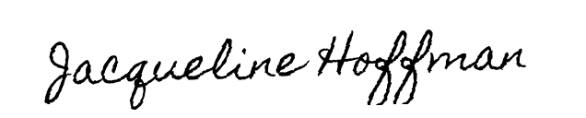

Landlord's Signature: __________________________

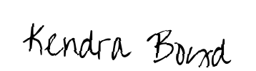

Tenant's Signature: __________________________