RESIDENTIAL LEASE AGREEMENT

1. THE PARTIES. This Residential Lease Agreement (“Agreement”) is made on February 02, 2025 by and between:

Landlord  
Name: Steven Taylor  
Mailing Address: PSC 3700, Box 3125, APO AE 62475

Tenant  
Name: Michelle Schwartz  
Mailing Address: 950 Ronald Court Apt. 615, Edwardsport, DE 71489

2. PROPERTY  
Property Address: 33968 John Path, Franklinville, WA 47202  
Residence Type: Townhouse  
Bedroom(s): 5 Bathroom(s): 1

3. TERM  
Start Date: March 02, 2025  
End Date: March 11, 2026

4. RENT  
Monthly Rent: $1098  
Due Date: 1st day of each month.

5. SECURITY DEPOSIT  
Amount: $2179

IN WITNESS WHEREOF, the Parties have executed this Agreement as of the date first above written.

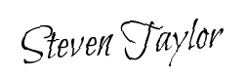

Landlord's Signature: __________________________

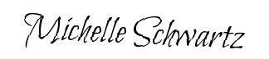

Tenant's Signature: __________________________