RESIDENTIAL LEASE AGREEMENT

1. THE PARTIES. This Residential Lease Agreement (“Agreement”) is made on February 02, 2025 by and between:

Landlord  
Name: Bonnie Oneal  
Mailing Address: 760 Rice Street, South Meganhaven, TN 36341

Tenant  
Name: Ms. Alicia Daniels  
Mailing Address: PSC 2289, Box 7956, APO AP 85788

2. PROPERTY  
Property Address: 288 Amy Pines, Grimesshire, KS 47863  
Residence Type: Apartment  
Bedroom(s): 5 Bathroom(s): 1

3. TERM  
Start Date: February 27, 2025  
End Date: December 16, 2026

4. RENT  
Monthly Rent: $2678  
Due Date: 1st day of each month.

5. SECURITY DEPOSIT  
Amount: $4215

IN WITNESS WHEREOF, the Parties have executed this Agreement as of the date first above written.

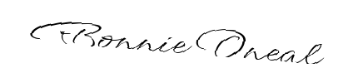

Landlord's Signature: __________________________

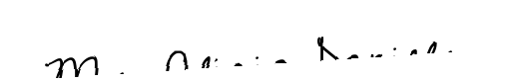

Tenant's Signature: __________________________