RESIDENTIAL LEASE AGREEMENT

1. THE PARTIES. This Residential Lease Agreement (“Agreement”) is made on February 02, 2025 by and between:

Landlord  
Name: Dr. Theresa Simpson DVM  
Mailing Address: 015 Susan Ville, South Cody, PR 82821

Tenant  
Name: Nicole Martinez  
Mailing Address: 705 Williams Gateway Suite 576, Samanthaview, IL 71747

2. PROPERTY  
Property Address: 111 Simpson Junctions, Emilytown, MI 83716  
Residence Type: House  
Bedroom(s): 4 Bathroom(s): 3

3. TERM  
Start Date: February 12, 2025  
End Date: March 06, 2026

4. RENT  
Monthly Rent: $2671  
Due Date: 1st day of each month.

5. SECURITY DEPOSIT  
Amount: $1781

IN WITNESS WHEREOF, the Parties have executed this Agreement as of the date first above written.

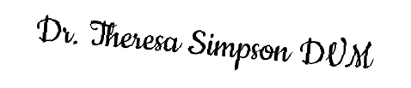

Landlord's Signature: __________________________



Tenant's Signature: __________________________