RESIDENTIAL LEASE AGREEMENT

1. THE PARTIES. This Residential Lease Agreement (“Agreement”) is made on February 05, 2025 by and between:

Landlord  
Name: Christine Nelson  
Mailing Address: 56645 Michael Ports, North Jessicaburgh, WI 34632

Tenant  
Name: Samuel Gonzales  
Mailing Address: 9616 Jacqueline Crescent, Brownhaven, MP 05299

2. PROPERTY  
Property Address: 987 Stephanie Extensions, New Jenniferville, LA 23482  
Residence Type: House  
Bedroom(s): 4 Bathroom(s): 3

3. TERM  
Start Date: March 01, 2025  
End Date: May 14, 2026

4. RENT  
Monthly Rent: $1005  
Due Date: 1st day of each month.

5. SECURITY DEPOSIT  
Amount: $4116

IN WITNESS WHEREOF, the Parties have executed this Agreement as of the date first above written.

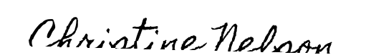

Landlord's Signature: __________________________

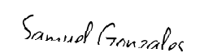

Tenant's Signature: __________________________