RESIDENTIAL LEASE AGREEMENT

1. THE PARTIES. This Residential Lease Agreement (“Agreement”) is made on February 03, 2025 by and between:

Landlord  
Name: Wesley Maldonado  
Mailing Address: 632 Sosa Valleys, Garciaburgh, TX 81209

Tenant  
Name: Todd Bennett  
Mailing Address: 526 Shane Pass, South Douglas, MH 64448

2. PROPERTY  
Property Address: 24164 Amanda Corners, Fryemouth, NM 91534  
Residence Type: House  
Bedroom(s): 2 Bathroom(s): 3

3. TERM  
Start Date: February 11, 2025  
End Date: October 23, 2026

4. RENT  
Monthly Rent: $2128  
Due Date: 1st day of each month.

5. SECURITY DEPOSIT  
Amount: $2398

IN WITNESS WHEREOF, the Parties have executed this Agreement as of the date first above written.

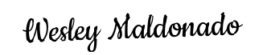

Landlord's Signature: __________________________

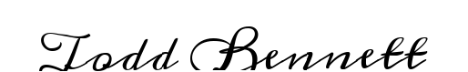

Tenant's Signature: __________________________