NON-DISCLOSURE AGREEMENT (NDA)

This Nondisclosure Agreement ("Agreement") is made on January 28, 2025 by and between the following parties:

Disclosing Party: Benjamin, Rodriguez and Wallace  
Address: 9661 Frost Road Suite 515, New Carrie, GU 36810

Receiving Party: Melissa Riley  
Address: 71566 Hensley Ferry, East Erinland, VA 37529

**1. Definition of Confidential Information:** Confidential Information includes all information or material that has, or could have, commercial value.

**2. Exclusions from Confidential Information:** Information that is publicly known at the time of disclosure is not considered confidential.

**3. Obligations of Receiving Party:** The Receiving Party agrees to maintain confidentiality and not disclose the information.

**4. Time Periods:** This Agreement remains in effect until the information is no longer confidential or upon mutual consent.

IN WITNESS WHEREOF, the parties have executed this Agreement as of the date first written above.

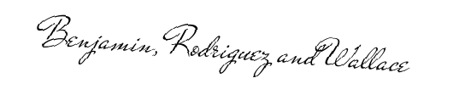

Disclosing Party's Signature: __________________________

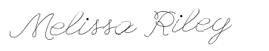

Receiving Party's Signature: __________________________