NON-DISCLOSURE AGREEMENT (NDA)

This Nondisclosure Agreement ("Agreement") is made on April 12, 2024 by and between the following parties:

Disclosing Party: Johnson LLC  
Address: 1047 Garcia Grove Suite 628, Websterfurt, NH 91380

Receiving Party: Robert Washington  
Address: USS Mccall, FPO AE 06459

**1. Definition of Confidential Information:** Confidential Information includes all information or material that has, or could have, commercial value.

**2. Exclusions from Confidential Information:** Information that is publicly known at the time of disclosure is not considered confidential.

**3. Obligations of Receiving Party:** The Receiving Party agrees to maintain confidentiality and not disclose the information.

**4. Time Periods:** This Agreement remains in effect until the information is no longer confidential or upon mutual consent.

IN WITNESS WHEREOF, the parties have executed this Agreement as of the date first written above.

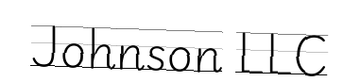

Disclosing Party's Signature: __________________________

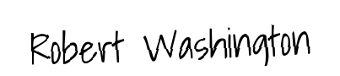

Receiving Party's Signature: __________________________