NON-DISCLOSURE AGREEMENT (NDA)

This Nondisclosure Agreement ("Agreement") is made on September 08, 2024 by and between the following parties:

Disclosing Party: Mullins, Gross and Hays  
Address: 93028 Williams Run Apt. 130, South Tammymouth, RI 34678

Receiving Party: Benjamin Gates  
Address: 661 Owens Field, Jonesbury, MH 09721

**1. Definition of Confidential Information:** Confidential Information includes all information or material that has, or could have, commercial value.

**2. Exclusions from Confidential Information:** Information that is publicly known at the time of disclosure is not considered confidential.

**3. Obligations of Receiving Party:** The Receiving Party agrees to maintain confidentiality and not disclose the information.

**4. Time Periods:** This Agreement remains in effect until the information is no longer confidential or upon mutual consent.

IN WITNESS WHEREOF, the parties have executed this Agreement as of the date first written above.

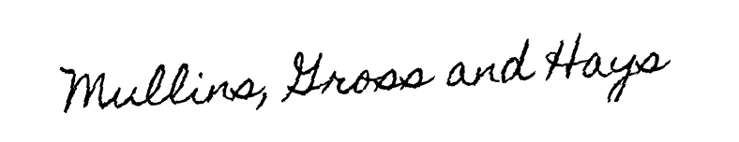

Disclosing Party's Signature: __________________________



Receiving Party's Signature: __________________________