PARTNERSHIP AGREEMENT

This PARTNERSHIP AGREEMENT ("Agreement") is made this April 07, 2024 by and between the following individuals:

Partner 1: Charles Martinez  
Address: 558 Adam Crossroad, Lake Annchester, CA 63377

Partner 2: Alison Braun  
Address: 94802 Diaz Prairie Apt. 362, Lake Victoria, MP 65961

**1. Nature of Business:** The partners listed above agree to form a partnership for the purpose of conducting the following business: Multi-lateral mission-critical task-force.

**2. Name of the Partnership:** The partnership shall operate under the name 'Allen and Sons' and maintain offices at [ADDRESS].

**3. Day-To-Day Operations:** The partners shall devote their full time and best efforts to the business. All partners will have equal management rights unless otherwise agreed upon.

**4. Capital Contributions:** Each partner agrees to contribute the following capital to the partnership:  
 - Charles Martinez: $10,000 (50% Share)  
 - Alison Braun: $10,000 (50% Share)

**5. Profits and Losses:** Profits and losses shall be divided according to the capital contributions of each partner unless otherwise agreed.

**6. Termination:** The partnership may be terminated upon mutual agreement. Upon termination, assets will be distributed based on each partner's share.

**7. Governing Law:** This Agreement shall be governed by the laws of the state of Oklahoma.

IN WITNESS WHEREOF, the parties have executed this Agreement as of the date first written above.

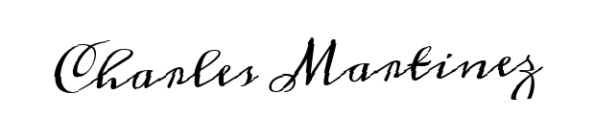

Partner 1's Signature: __________________________

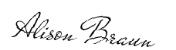

Partner 2's Signature: __________________________