PARTNERSHIP AGREEMENT

This PARTNERSHIP AGREEMENT ("Agreement") is made this November 23, 2024 by and between the following individuals:

Partner 1: Jacob Waters  
Address: 2361 Jefferson Island Apt. 006, Browningbury, DC 72983

Partner 2: Renee Hunter  
Address: 9216 Kelly Island Suite 248, Antoniofurt, WY 99036

**1. Nature of Business:** The partners listed above agree to form a partnership for the purpose of conducting the following business: Implemented neutral conglomeration.

**2. Name of the Partnership:** The partnership shall operate under the name 'Nguyen, Baker and Mccann' and maintain offices at [ADDRESS].

**3. Day-To-Day Operations:** The partners shall devote their full time and best efforts to the business. All partners will have equal management rights unless otherwise agreed upon.

**4. Capital Contributions:** Each partner agrees to contribute the following capital to the partnership:  
 - Jacob Waters: $10,000 (50% Share)  
 - Renee Hunter: $10,000 (50% Share)

**5. Profits and Losses:** Profits and losses shall be divided according to the capital contributions of each partner unless otherwise agreed.

**6. Termination:** The partnership may be terminated upon mutual agreement. Upon termination, assets will be distributed based on each partner's share.

**7. Governing Law:** This Agreement shall be governed by the laws of the state of Oregon.

IN WITNESS WHEREOF, the parties have executed this Agreement as of the date first written above.

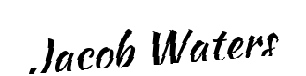

Partner 1's Signature: __________________________

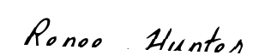

Partner 2's Signature: __________________________