PARTNERSHIP AGREEMENT

This PARTNERSHIP AGREEMENT ("Agreement") is made this October 22, 2024 by and between the following individuals:

Partner 1: Jason Sanford  
Address: 404 John Parks, Nelsonport, DE 16140

Partner 2: Heather Pacheco  
Address: 90600 Walker Extension Apt. 568, Lake Kristiland, NH 43673

**1. Nature of Business:** The partners listed above agree to form a partnership for the purpose of conducting the following business: Managed 24hour analyzer.

**2. Name of the Partnership:** The partnership shall operate under the name 'Brewer and Sons' and maintain offices at [ADDRESS].

**3. Day-To-Day Operations:** The partners shall devote their full time and best efforts to the business. All partners will have equal management rights unless otherwise agreed upon.

**4. Capital Contributions:** Each partner agrees to contribute the following capital to the partnership:  
 - Jason Sanford: $10,000 (50% Share)  
 - Heather Pacheco: $10,000 (50% Share)

**5. Profits and Losses:** Profits and losses shall be divided according to the capital contributions of each partner unless otherwise agreed.

**6. Termination:** The partnership may be terminated upon mutual agreement. Upon termination, assets will be distributed based on each partner's share.

**7. Governing Law:** This Agreement shall be governed by the laws of the state of Maryland.

IN WITNESS WHEREOF, the parties have executed this Agreement as of the date first written above.

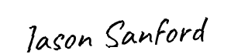

Partner 1's Signature: __________________________

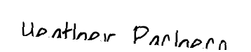

Partner 2's Signature: __________________________