PARTNERSHIP AGREEMENT

This PARTNERSHIP AGREEMENT ("Agreement") is made this March 17, 2024 by and between the following individuals:

Partner 1: Jennifer Mitchell  
Address: 098 Maria Radial Suite 061, East Davidville, VA 42087

Partner 2: Diana Clark  
Address: 58694 John Keys, Jerryshire, NJ 43698

**1. Nature of Business:** The partners listed above agree to form a partnership for the purpose of conducting the following business: Self-enabling content-based support.

**2. Name of the Partnership:** The partnership shall operate under the name 'Nichols, Garcia and Sanchez' and maintain offices at [ADDRESS].

**3. Day-To-Day Operations:** The partners shall devote their full time and best efforts to the business. All partners will have equal management rights unless otherwise agreed upon.

**4. Capital Contributions:** Each partner agrees to contribute the following capital to the partnership:  
 - Jennifer Mitchell: $10,000 (50% Share)  
 - Diana Clark: $10,000 (50% Share)

**5. Profits and Losses:** Profits and losses shall be divided according to the capital contributions of each partner unless otherwise agreed.

**6. Termination:** The partnership may be terminated upon mutual agreement. Upon termination, assets will be distributed based on each partner's share.

**7. Governing Law:** This Agreement shall be governed by the laws of the state of Georgia.

IN WITNESS WHEREOF, the parties have executed this Agreement as of the date first written above.

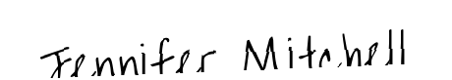

Partner 1's Signature: __________________________

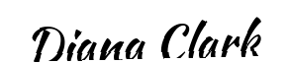

Partner 2's Signature: __________________________