PARTNERSHIP AGREEMENT

This PARTNERSHIP AGREEMENT ("Agreement") is made this October 23, 2024 by and between the following individuals:

Partner 1: Kyle Romero  
Address: 614 Christopher Road, Smithland, WI 71928

Partner 2: Claudia Gates  
Address: 83722 Cheyenne Groves Apt. 208, New Arthurview, NY 11510

**1. Nature of Business:** The partners listed above agree to form a partnership for the purpose of conducting the following business: Diverse mobile challenge.

**2. Name of the Partnership:** The partnership shall operate under the name 'Thompson, Cooper and Cooley' and maintain offices at [ADDRESS].

**3. Day-To-Day Operations:** The partners shall devote their full time and best efforts to the business. All partners will have equal management rights unless otherwise agreed upon.

**4. Capital Contributions:** Each partner agrees to contribute the following capital to the partnership:  
 - Kyle Romero: $10,000 (50% Share)  
 - Claudia Gates: $10,000 (50% Share)

**5. Profits and Losses:** Profits and losses shall be divided according to the capital contributions of each partner unless otherwise agreed.

**6. Termination:** The partnership may be terminated upon mutual agreement. Upon termination, assets will be distributed based on each partner's share.

**7. Governing Law:** This Agreement shall be governed by the laws of the state of Oklahoma.

IN WITNESS WHEREOF, the parties have executed this Agreement as of the date first written above.

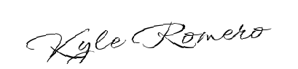

Partner 1's Signature: __________________________

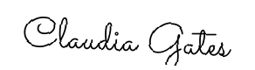

Partner 2's Signature: __________________________