PARTNERSHIP AGREEMENT

This PARTNERSHIP AGREEMENT ("Agreement") is made this March 27, 2024 by and between the following individuals:

Partner 1: Margaret Pollard  
Address: 3343 Johnson Junctions, Darrenbury, UT 46561

Partner 2: Wendy Knox  
Address: 296 Clarke Hills Suite 104, Phelpsmouth, WI 99358

**1. Nature of Business:** The partners listed above agree to form a partnership for the purpose of conducting the following business: Visionary didactic superstructure.

**2. Name of the Partnership:** The partnership shall operate under the name 'Smith, Cruz and Cox' and maintain offices at [ADDRESS].

**3. Day-To-Day Operations:** The partners shall devote their full time and best efforts to the business. All partners will have equal management rights unless otherwise agreed upon.

**4. Capital Contributions:** Each partner agrees to contribute the following capital to the partnership:  
 - Margaret Pollard: $10,000 (50% Share)  
 - Wendy Knox: $10,000 (50% Share)

**5. Profits and Losses:** Profits and losses shall be divided according to the capital contributions of each partner unless otherwise agreed.

**6. Termination:** The partnership may be terminated upon mutual agreement. Upon termination, assets will be distributed based on each partner's share.

**7. Governing Law:** This Agreement shall be governed by the laws of the state of Maine.

IN WITNESS WHEREOF, the parties have executed this Agreement as of the date first written above.

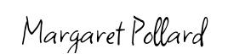

Partner 1's Signature: __________________________

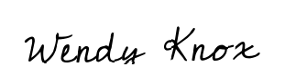

Partner 2's Signature: __________________________