PARTNERSHIP AGREEMENT

This PARTNERSHIP AGREEMENT ("Agreement") is made this December 24, 2024 by and between the following individuals:

Partner 1: Samantha Gallegos  
Address: 897 Douglas Hill Suite 255, South Hayley, PW 74678

Partner 2: Jeremy Spears  
Address: 6694 Tracy Orchard Suite 385, Lake Dustinborough, SC 78941

**1. Nature of Business:** The partners listed above agree to form a partnership for the purpose of conducting the following business: Synergistic real-time intranet.

**2. Name of the Partnership:** The partnership shall operate under the name 'Tran LLC' and maintain offices at [ADDRESS].

**3. Day-To-Day Operations:** The partners shall devote their full time and best efforts to the business. All partners will have equal management rights unless otherwise agreed upon.

**4. Capital Contributions:** Each partner agrees to contribute the following capital to the partnership:  
 - Samantha Gallegos: $10,000 (50% Share)  
 - Jeremy Spears: $10,000 (50% Share)

**5. Profits and Losses:** Profits and losses shall be divided according to the capital contributions of each partner unless otherwise agreed.

**6. Termination:** The partnership may be terminated upon mutual agreement. Upon termination, assets will be distributed based on each partner's share.

**7. Governing Law:** This Agreement shall be governed by the laws of the state of Louisiana.

IN WITNESS WHEREOF, the parties have executed this Agreement as of the date first written above.

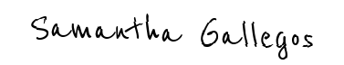

Partner 1's Signature: __________________________

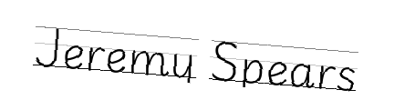

Partner 2's Signature: __________________________