PARTNERSHIP AGREEMENT

This PARTNERSHIP AGREEMENT ("Agreement") is made this October 09, 2024 by and between the following individuals:

Partner 1: Sarah Pena  
Address: 99494 Cantu Radial, Lake Kristenville, FL 21658

Partner 2: Caitlin Weber  
Address: 0879 Collins Islands Suite 730, South Tracey, RI 02574

**1. Nature of Business:** The partners listed above agree to form a partnership for the purpose of conducting the following business: Decentralized systematic model.

**2. Name of the Partnership:** The partnership shall operate under the name 'Aguilar PLC' and maintain offices at [ADDRESS].

**3. Day-To-Day Operations:** The partners shall devote their full time and best efforts to the business. All partners will have equal management rights unless otherwise agreed upon.

**4. Capital Contributions:** Each partner agrees to contribute the following capital to the partnership:  
 - Sarah Pena: $10,000 (50% Share)  
 - Caitlin Weber: $10,000 (50% Share)

**5. Profits and Losses:** Profits and losses shall be divided according to the capital contributions of each partner unless otherwise agreed.

**6. Termination:** The partnership may be terminated upon mutual agreement. Upon termination, assets will be distributed based on each partner's share.

**7. Governing Law:** This Agreement shall be governed by the laws of the state of Michigan.

IN WITNESS WHEREOF, the parties have executed this Agreement as of the date first written above.

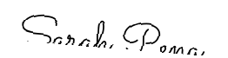

Partner 1's Signature: __________________________

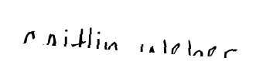

Partner 2's Signature: __________________________