PARTNERSHIP AGREEMENT

This PARTNERSHIP AGREEMENT ("Agreement") is made this June 10, 2024 by and between the following individuals:

Partner 1: Tracy Cox  
Address: 50129 Richard Tunnel, Kellystad, AZ 32323

Partner 2: Cheryl Edwards  
Address: 559 Perez Skyway Suite 633, Lake Adam, VT 42222

**1. Nature of Business:** The partners listed above agree to form a partnership for the purpose of conducting the following business: Organic secondary attitude.

**2. Name of the Partnership:** The partnership shall operate under the name 'Harrell, Weber and Boyd' and maintain offices at [ADDRESS].

**3. Day-To-Day Operations:** The partners shall devote their full time and best efforts to the business. All partners will have equal management rights unless otherwise agreed upon.

**4. Capital Contributions:** Each partner agrees to contribute the following capital to the partnership:  
 - Tracy Cox: $10,000 (50% Share)  
 - Cheryl Edwards: $10,000 (50% Share)

**5. Profits and Losses:** Profits and losses shall be divided according to the capital contributions of each partner unless otherwise agreed.

**6. Termination:** The partnership may be terminated upon mutual agreement. Upon termination, assets will be distributed based on each partner's share.

**7. Governing Law:** This Agreement shall be governed by the laws of the state of New York.

IN WITNESS WHEREOF, the parties have executed this Agreement as of the date first written above.

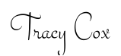

Partner 1's Signature: __________________________

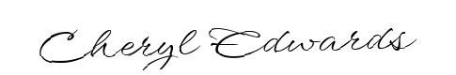

Partner 2's Signature: __________________________