RESIGNATION LETTER

From:

Douglas Green

6219 Carpenter Brook Apt. 157  
Francisbury, AZ 57963

1970-12-07

To:

Daniel Patterson

231 Bradley Valleys  
Andrewfort, DC 51304

RE: Resignation

Dear Daniel Patterson,

Please accept this letter as my formal resignation from my position as Mid Software Engineer at Hall, Jones and Henderson, effective 4 weeks from today’s date, 1970-12-07.

I appreciate the opportunities for growth and development you have provided during my tenure. Thank you for your repeated guidance and support.

Please let me know how I can be of help during the transition period. I wish you and the company the very best going forward.

Sincerely,

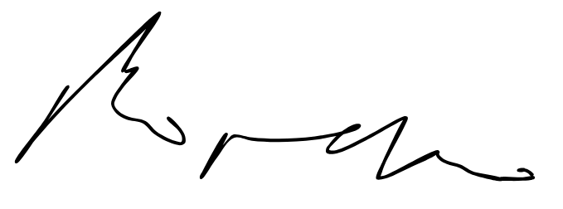

Douglas Green