RESIGNATION LETTER

From:

Elizabeth Campbell

0267 Hamilton Spurs Apt. 819  
Lake Joan, MN 61597

2022-02-24

To:

Carolyn Thomas

76623 Bennett Vista  
Ellisonmouth, WY 16952

RE: Resignation

Dear Carolyn Thomas,

Please accept this letter as my formal resignation from my position as Mid Cloud Architect at Miller, Walton and Garcia, effective 6 weeks from today’s date, 2022-02-24.

I appreciate the opportunities for growth and development you have provided during my tenure. Thank you for your repeated guidance and support.

Please let me know how I can be of help during the transition period. I wish you and the company the very best going forward.

Sincerely,

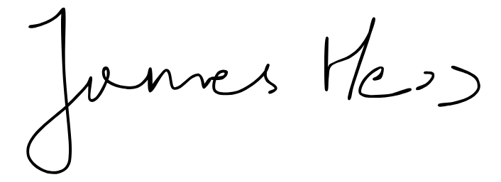

Elizabeth Campbell