RESIGNATION LETTER

From:

Trevor Hughes

59239 Brewer Gardens  
New Ashleyport, AS 91352

2021-05-27

To:

Melissa Smith

06254 Grant Freeway Apt. 367  
Robertshire, OH 14519

RE: Resignation

Dear Melissa Smith,

Please accept this letter as my formal resignation from my position as Senior DevOps at Dean, Ayers and Gallegos, effective 3 weeks from today’s date, 2021-05-27.

I appreciate the opportunities for growth and development you have provided during my tenure. Thank you for your repeated guidance and support.

Please let me know how I can be of help during the transition period. I wish you and the company the very best going forward.

Sincerely,

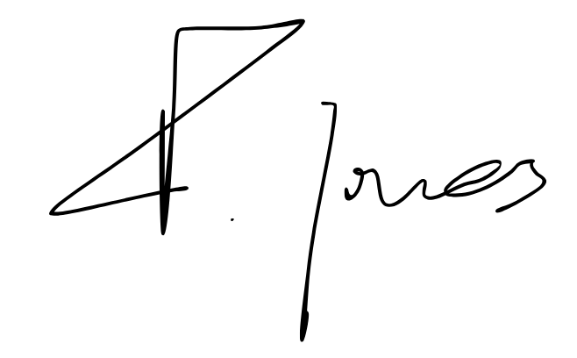

Trevor Hughes