RESIGNATION LETTER

From:

Robert Carpenter

1898 Long Roads Suite 680  
Butlertown, PA 41854

2013-12-08

To:

Andrea Dickson

1623 Haney Inlet  
Huntstad, AS 69379

RE: Resignation

Dear Andrea Dickson,

Please accept this letter as my formal resignation from my position as Staff Software Engineer at Green LLC, effective 11 weeks from today’s date, 2013-12-08.

I appreciate the opportunities for growth and development you have provided during my tenure. Thank you for your repeated guidance and support.

Please let me know how I can be of help during the transition period. I wish you and the company the very best going forward.

Sincerely,

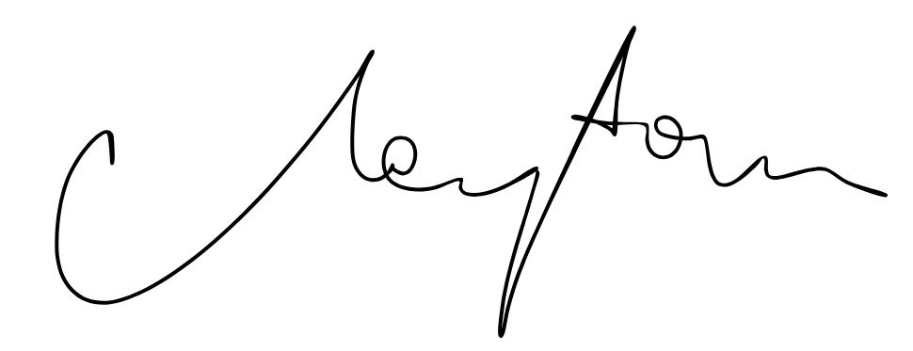

Robert Carpenter