RESIGNATION LETTER

From:

Kristen Hampton

6957 Farmer Parkway  
East Jenniferview, NC 12868

1987-01-11

To:

Cheryl Bradley

5131 Fitzgerald Tunnel Apt. 982  
Mcculloughtown, AS 44497

RE: Resignation

Dear Cheryl Bradley,

Please accept this letter as my formal resignation from my position as Staff Data Analyst at Henry-Martin, effective 5 weeks from today’s date, 1987-01-11.

I appreciate the opportunities for growth and development you have provided during my tenure. Thank you for your repeated guidance and support.

Please let me know how I can be of help during the transition period. I wish you and the company the very best going forward.

Sincerely,

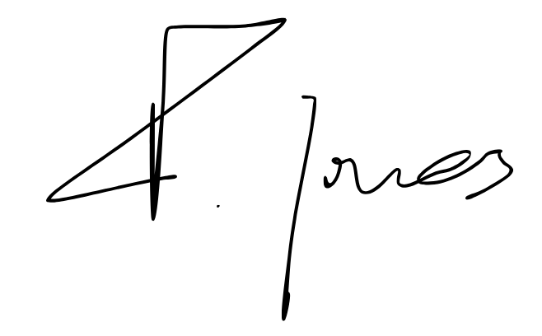

Kristen Hampton