RESIGNATION LETTER

From:

Kari Ramsey

19996 Alvarado Loaf  
Brucefort, ME 55469

1970-07-15

To:

Lisa Bates

928 Taylor Village Apt. 999  
North Petershire, MO 39911

RE: Resignation

Dear Lisa Bates,

Please accept this letter as my formal resignation from my position as Junior Cloud Architect at Brown-Lee, effective 12 weeks from today’s date, 1970-07-15.

I appreciate the opportunities for growth and development you have provided during my tenure. Thank you for your repeated guidance and support.

Please let me know how I can be of help during the transition period. I wish you and the company the very best going forward.

Sincerely,

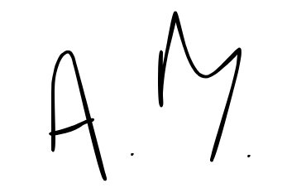

Kari Ramsey