RESIGNATION LETTER

From:

Kathleen Medina

6048 Christian Isle  
North Lauraborough, MH 81424

1983-12-04

To:

Cynthia Kelly DDS

27518 Lisa Union  
Thomasburgh, FL 94168

RE: Resignation

Dear Cynthia Kelly DDS,

Please accept this letter as my formal resignation from my position as Staff Cloud Architect at Knight-Jenkins, effective 8 weeks from today’s date, 1983-12-04.

I appreciate the opportunities for growth and development you have provided during my tenure. Thank you for your repeated guidance and support.

Please let me know how I can be of help during the transition period. I wish you and the company the very best going forward.

Sincerely,

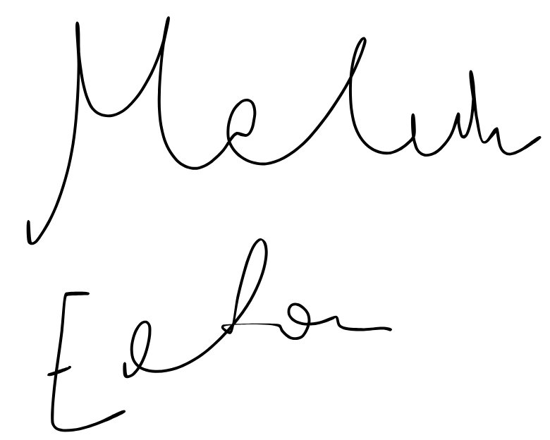

Kathleen Medina