RESIGNATION LETTER

From:

Mark Brooks

4449 Tucker Burgs  
Jaredborough, WA 18224

2003-02-09

To:

Lisa Farrell

13711 Ruiz Terrace Suite 520  
Ashleyhaven, NJ 15914

RE: Resignation

Dear Lisa Farrell,

Please accept this letter as my formal resignation from my position as Senior Data Analyst at Griffin, Cantrell and Hanson, effective 12 weeks from today’s date, 2003-02-09.

I appreciate the opportunities for growth and development you have provided during my tenure. Thank you for your repeated guidance and support.

Please let me know how I can be of help during the transition period. I wish you and the company the very best going forward.

Sincerely,

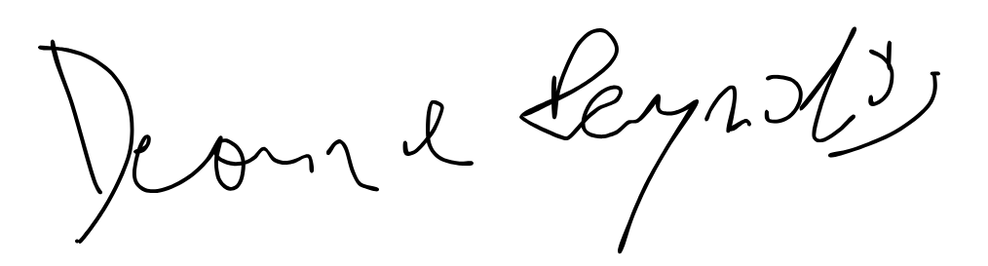

Mark Brooks