RESIGNATION LETTER

From:

Rhonda Morgan

789 Tracey Isle Apt. 602  
Lake Joshua, VI 78146

2008-09-25

To:

Lauren Sullivan

294 Kevin Cliff  
Garystad, VA 95585

RE: Resignation

Dear Lauren Sullivan,

Please accept this letter as my formal resignation from my position as Senior Cloud Architect at Carrillo-Cox, effective 5 weeks from today’s date, 2008-09-25.

I appreciate the opportunities for growth and development you have provided during my tenure. Thank you for your repeated guidance and support.

Please let me know how I can be of help during the transition period. I wish you and the company the very best going forward.

Sincerely,

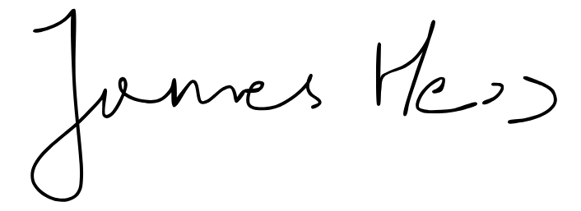

Rhonda Morgan