RESIGNATION LETTER

From:

Daniel Owen

8951 Mcgee Orchard Suite 898  
Port Jerryfurt, SC 37827

1981-08-05

To:

Meagan Ramirez

22448 Zachary Squares  
Boyerberg, NY 43620

RE: Resignation

Dear Meagan Ramirez,

Please accept this letter as my formal resignation from my position as Mid Site Reliability Engineer at Horn, Figueroa and Jacobs, effective 11 weeks from today’s date, 1981-08-05.

I appreciate the opportunities for growth and development you have provided during my tenure. Thank you for your repeated guidance and support.

Please let me know how I can be of help during the transition period. I wish you and the company the very best going forward.

Sincerely,

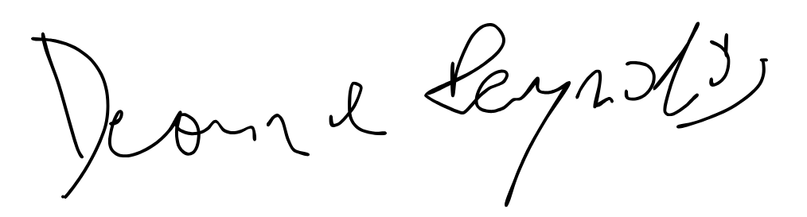

Daniel Owen