RESIGNATION LETTER

From:

Trevor Myers

24946 Thomas Court  
North Kyle, ND 72087

2012-10-18

To:

Stephen Ruiz

7656 Matthew Keys Suite 369  
West Elizabethtown, MP 68444

RE: Resignation

Dear Stephen Ruiz,

Please accept this letter as my formal resignation from my position as Junior Cloud Architect at Brown Ltd, effective 8 weeks from today’s date, 2012-10-18.

I appreciate the opportunities for growth and development you have provided during my tenure. Thank you for your repeated guidance and support.

Please let me know how I can be of help during the transition period. I wish you and the company the very best going forward.

Sincerely,

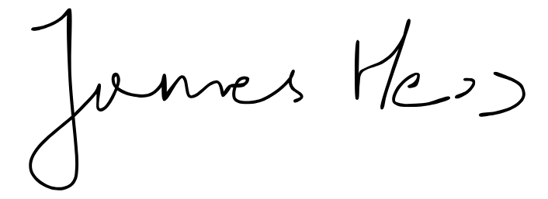

Trevor Myers