RESIGNATION LETTER

From:

Amy Griffin

508 Gary View Suite 669  
South Williamhaven, FL 76356

1983-06-27

To:

Alan Wilson

PSC 5823, Box 6059  
APO AP 63576

RE: Resignation

Dear Alan Wilson,

Please accept this letter as my formal resignation from my position as Staff Software Engineer at Estes, Allen and Hill, effective 6 weeks from today’s date, 1983-06-27.

I appreciate the opportunities for growth and development you have provided during my tenure. Thank you for your repeated guidance and support.

Please let me know how I can be of help during the transition period. I wish you and the company the very best going forward.

Sincerely,

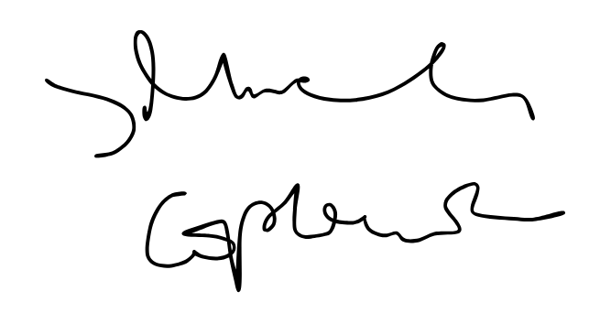

Amy Griffin