RESIGNATION LETTER

From:

Yolanda Pearson

4003 Michelle Ford  
Port Brandimouth, MO 36729

2005-06-07

To:

Brianna Valentine

3739 Ashley Fort  
West Dalton, MO 03041

RE: Resignation

Dear Brianna Valentine,

Please accept this letter as my formal resignation from my position as Mid Cloud Architect at Johnson-Morales, effective 8 weeks from today’s date, 2005-06-07.

I appreciate the opportunities for growth and development you have provided during my tenure. Thank you for your repeated guidance and support.

Please let me know how I can be of help during the transition period. I wish you and the company the very best going forward.

Sincerely,

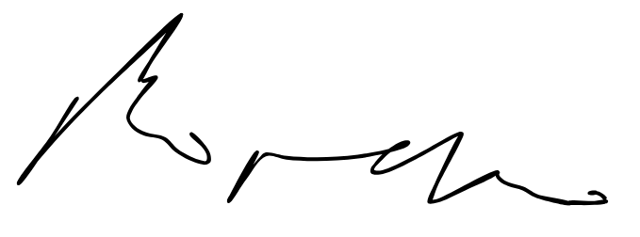

Yolanda Pearson