RESIGNATION LETTER

From:

Richard Warren

65919 Williams Branch  
Kimfort, AS 26235

1970-12-20

To:

Marcus Burke

921 Manning Alley Suite 279  
Denisemouth, NM 75056

RE: Resignation

Dear Marcus Burke,

Please accept this letter as my formal resignation from my position as Mid Cloud Architect at Casey, Prince and Wright, effective 4 weeks from today’s date, 1970-12-20.

I appreciate the opportunities for growth and development you have provided during my tenure. Thank you for your repeated guidance and support.

Please let me know how I can be of help during the transition period. I wish you and the company the very best going forward.

Sincerely,

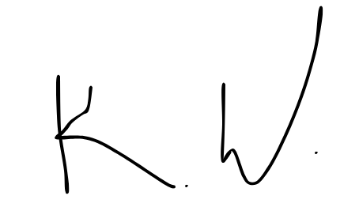

Richard Warren