RESIGNATION LETTER

From:

April Dean

469 Li Drives Apt. 223  
East Jacqueline, PW 50257

1995-04-18

To:

Jacqueline Barnett

601 Flores View Apt. 893  
New Robert, VT 26298

RE: Resignation

Dear Jacqueline Barnett,

Please accept this letter as my formal resignation from my position as Mid DevOps at Sims-Price, effective 9 weeks from today’s date, 1995-04-18.

I appreciate the opportunities for growth and development you have provided during my tenure. Thank you for your repeated guidance and support.

Please let me know how I can be of help during the transition period. I wish you and the company the very best going forward.

Sincerely,

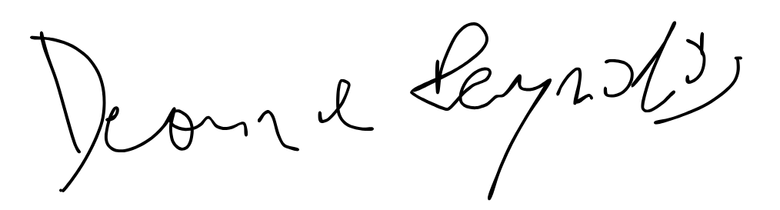

April Dean