RESIGNATION LETTER

From:

David Johnston

709 Taylor Inlet Apt. 078  
Paulview, NH 55329

1991-10-27

To:

Deborah Barron

130 Alexandria Cliffs Apt. 449  
Jacquelineborough, ND 30575

RE: Resignation

Dear Deborah Barron,

Please accept this letter as my formal resignation from my position as Senior DevOps at Gibbs and Sons, effective 9 weeks from today’s date, 1991-10-27.

I appreciate the opportunities for growth and development you have provided during my tenure. Thank you for your repeated guidance and support.

Please let me know how I can be of help during the transition period. I wish you and the company the very best going forward.

Sincerely,

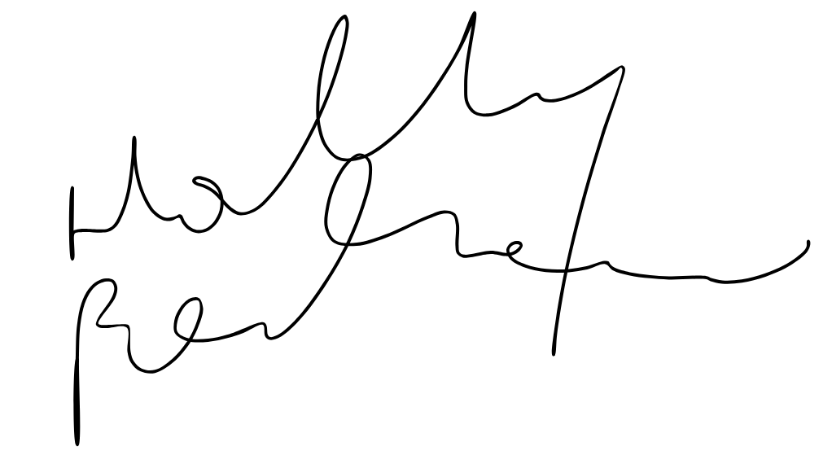

David Johnston