RESIGNATION LETTER

From:

Casey Mayer

217 Lam Street Apt. 601  
Joneston, CT 70060

1973-04-17

To:

Mary Robinson

471 Browning Via Suite 934  
Dennisbury, NH 54701

RE: Resignation

Dear Mary Robinson,

Please accept this letter as my formal resignation from my position as Mid DevOps at Russell LLC, effective 10 weeks from today’s date, 1973-04-17.

I appreciate the opportunities for growth and development you have provided during my tenure. Thank you for your repeated guidance and support.

Please let me know how I can be of help during the transition period. I wish you and the company the very best going forward.

Sincerely,

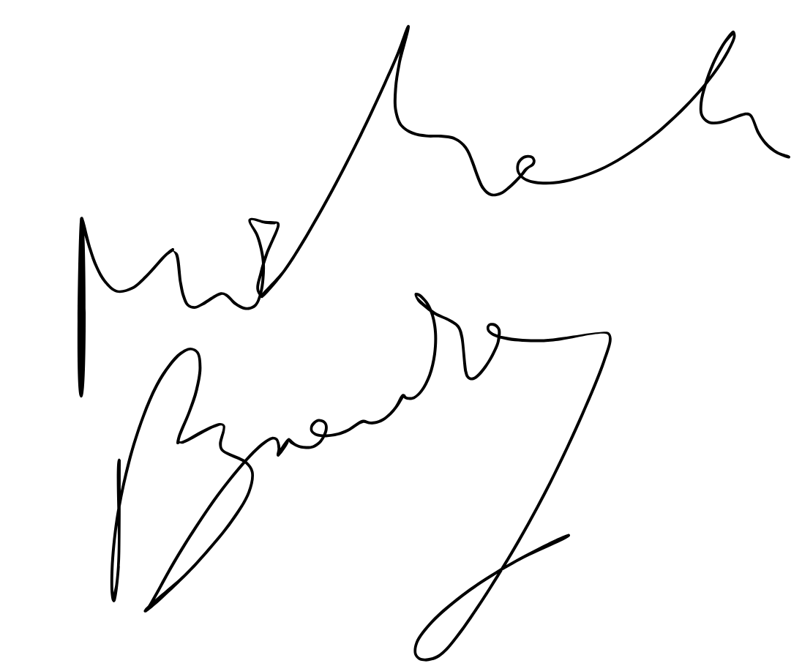

Casey Mayer