RESIGNATION LETTER

From:

Cynthia Ortiz

223 Pitts Fort Apt. 936  
New Ashley, AL 93036

1991-09-14

To:

Cody Dudley

742 Bond Divide  
North Ashleyville, KY 52542

RE: Resignation

Dear Cody Dudley,

Please accept this letter as my formal resignation from my position as Mid Software Engineer at Houston Ltd, effective 3 weeks from today’s date, 1991-09-14.

I appreciate the opportunities for growth and development you have provided during my tenure. Thank you for your repeated guidance and support.

Please let me know how I can be of help during the transition period. I wish you and the company the very best going forward.

Sincerely,

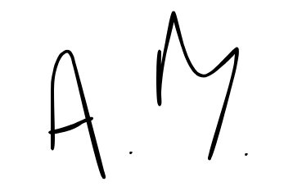

Cynthia Ortiz