RESIGNATION LETTER

From:
Douglas Green
6219 Carpenter Brook Apt. 157
Francisbury, AZ 57963
1970-12-07

To:
Daniel Patterson
231 Bradley Valleys
Andrewfort, DC 51304

RE: Resignation

Dear Daniel Patterson,
Please accept this letter as my formal resignation from my position as Mid Software Engineer at Hall, Jones and Henderson, effective 4 weeks from today’s date, 1970-12-07.
I appreciate the opportunities for growth and development you have provided during my tenure. Thank you for your repeated guidance and support.
Please let me know how I can be of help during the transition period. I wish you and the company the very best going forward.

Sincerely,

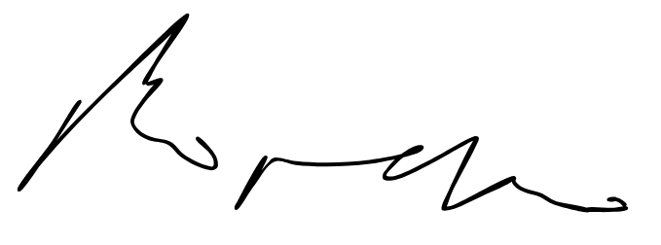

Douglas Green

