RESIGNATION LETTER

From:
Trevor Hughes
59239 Brewer Gardens
New Ashleyport, AS 91352
2021-05-27

To:
Melissa Smith
06254 Grant Freeway Apt. 367
Robertshire, OH 14519

RE: Resignation

Dear Melissa Smith,
Please accept this letter as my formal resignation from my position as Senior DevOps at Dean, Ayers and Gallegos, effective 3 weeks from today’s date, 2021-05-27.
I appreciate the opportunities for growth and development you have provided during my tenure. Thank you for your repeated guidance and support.
Please let me know how I can be of help during the transition period. I wish you and the company the very best going forward.

Sincerely,

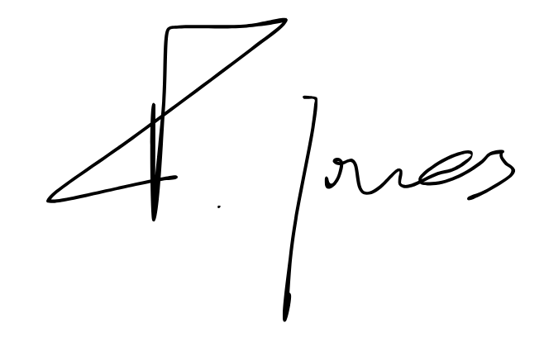

Trevor Hughes

