RESIGNATION LETTER

From:
Robert Carpenter
1898 Long Roads Suite 680
Butlertown, PA 41854
2013-12-08

To:
Andrea Dickson
1623 Haney Inlet
Huntstad, AS 69379

RE: Resignation

Dear Andrea Dickson,
Please accept this letter as my formal resignation from my position as Staff Software Engineer at Green LLC, effective 11 weeks from today’s date, 2013-12-08.
I appreciate the opportunities for growth and development you have provided during my tenure. Thank you for your repeated guidance and support.
Please let me know how I can be of help during the transition period. I wish you and the company the very best going forward.

Sincerely,

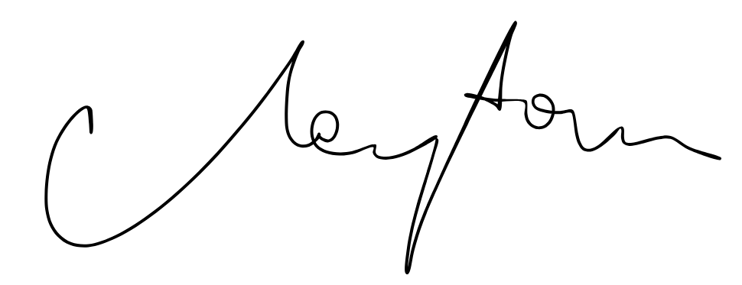

Robert Carpenter

