RESIGNATION LETTER

From:
Kari Ramsey
19996 Alvarado Loaf
Brucefort, ME 55469
1970-07-15

To:
Lisa Bates
928 Taylor Village Apt. 999
North Petershire, MO 39911

RE: Resignation

Dear Lisa Bates,
Please accept this letter as my formal resignation from my position as Junior Cloud Architect at Brown-Lee, effective 12 weeks from today’s date, 1970-07-15.
I appreciate the opportunities for growth and development you have provided during my tenure. Thank you for your repeated guidance and support.
Please let me know how I can be of help during the transition period. I wish you and the company the very best going forward.

Sincerely,

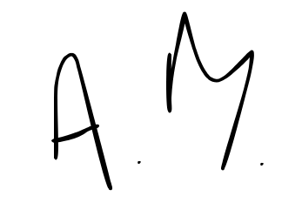

Kari Ramsey

