RESIGNATION LETTER

From:
John Miller
87362 Turner Crossing
Stewartville, MS 15591
1972-10-05

To:
Justin Hamilton
Unit 5283 Box 7022
DPO AP 53031

RE: Resignation

Dear Justin Hamilton,
Please accept this letter as my formal resignation from my position as Mid Data Analyst at Brown-Cunningham, effective 7 weeks from today’s date, 1972-10-05.
I appreciate the opportunities for growth and development you have provided during my tenure. Thank you for your repeated guidance and support.
Please let me know how I can be of help during the transition period. I wish you and the company the very best going forward.

Sincerely,

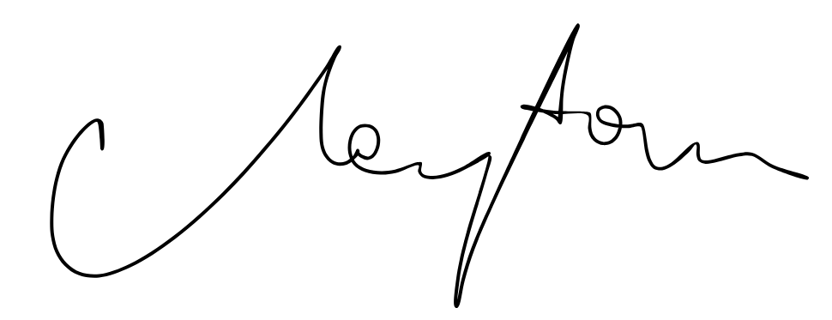

John Miller

