RESIGNATION LETTER

From:
Kathleen Medina
6048 Christian Isle
North Lauraborough, MH 81424
1983-12-04

To:
Cynthia Kelly DDS
27518 Lisa Union
Thomasburgh, FL 94168

RE: Resignation

Dear Cynthia Kelly DDS,
Please accept this letter as my formal resignation from my position as Staff Cloud Architect at Knight-Jenkins, effective 8 weeks from today’s date, 1983-12-04.
I appreciate the opportunities for growth and development you have provided during my tenure. Thank you for your repeated guidance and support.
Please let me know how I can be of help during the transition period. I wish you and the company the very best going forward.

Sincerely,

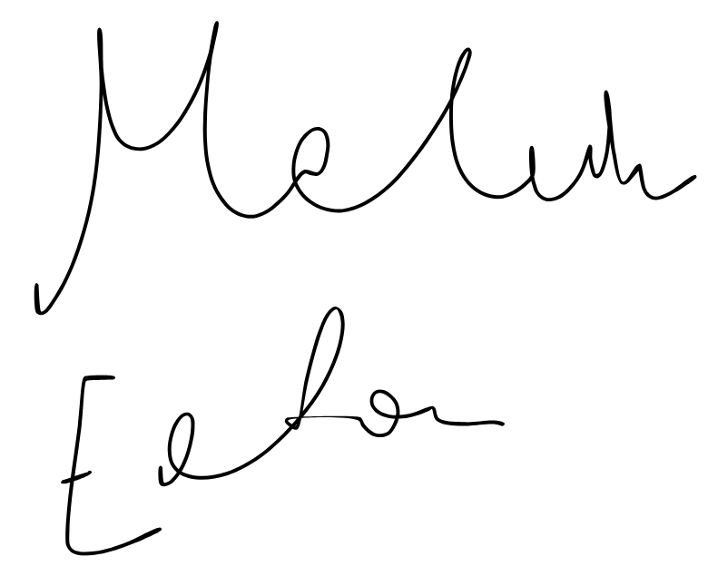

Kathleen Medina

