RESIGNATION LETTER

From:
Stephen Anthony
7123 Garner Corner
Lake Raymondhaven, VA 26736
1981-12-14

To:
Robert Bush
5000 Chelsea Passage
Anthonyborough, PR 47839

RE: Resignation

Dear Robert Bush,
Please accept this letter as my formal resignation from my position as Senior Data Analyst at Peterson Inc, effective 3 weeks from today’s date, 1981-12-14.
I appreciate the opportunities for growth and development you have provided during my tenure. Thank you for your repeated guidance and support.
Please let me know how I can be of help during the transition period. I wish you and the company the very best going forward.

Sincerely,

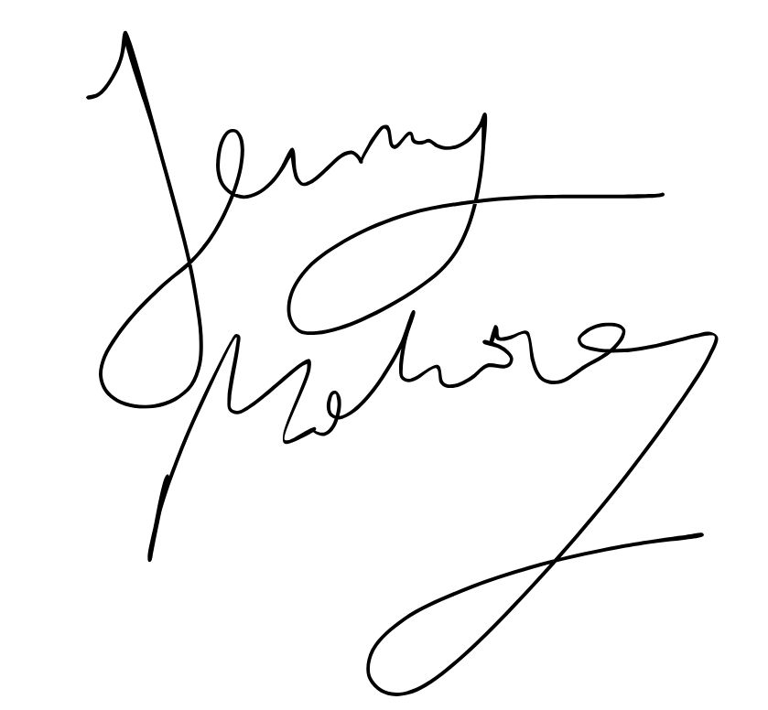

Stephen Anthony

