RESIGNATION LETTER

From:
Rhonda Morgan
789 Tracey Isle Apt. 602
Lake Joshua, VI 78146
2008-09-25

To:
Lauren Sullivan
294 Kevin Cliff
Garystad, VA 95585

RE: Resignation

Dear Lauren Sullivan,
Please accept this letter as my formal resignation from my position as Senior Cloud Architect at Carrillo-Cox, effective 5 weeks from today’s date, 2008-09-25.
I appreciate the opportunities for growth and development you have provided during my tenure. Thank you for your repeated guidance and support.
Please let me know how I can be of help during the transition period. I wish you and the company the very best going forward.

Sincerely,

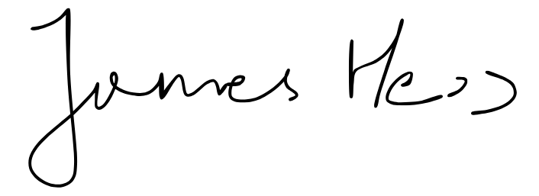

Rhonda Morgan

