RESIGNATION LETTER

From:
Daniel Owen
8951 Mcgee Orchard Suite 898
Port Jerryfurt, SC 37827
1981-08-05

To:
Meagan Ramirez
22448 Zachary Squares
Boyerberg, NY 43620

RE: Resignation

Dear Meagan Ramirez,
Please accept this letter as my formal resignation from my position as Mid Site Reliability Engineer at Horn, Figueroa and Jacobs, effective 11 weeks from today’s date, 1981-08-05.
I appreciate the opportunities for growth and development you have provided during my tenure. Thank you for your repeated guidance and support.
Please let me know how I can be of help during the transition period. I wish you and the company the very best going forward.

Sincerely,

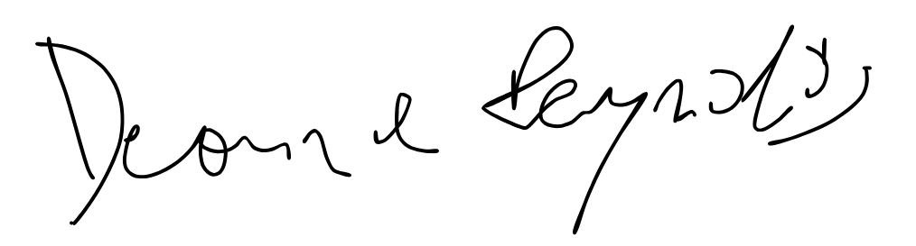

Daniel Owen

