RESIGNATION LETTER

From:
David Johnston
709 Taylor Inlet Apt. 078
Paulview, NH 55329
1991-10-27

To:
Deborah Barron
130 Alexandria Cliffs Apt. 449
Jacquelineborough, ND 30575

RE: Resignation

Dear Deborah Barron,
Please accept this letter as my formal resignation from my position as Senior DevOps at Gibbs and Sons, effective 9 weeks from today’s date, 1991-10-27.
I appreciate the opportunities for growth and development you have provided during my tenure. Thank you for your repeated guidance and support.
Please let me know how I can be of help during the transition period. I wish you and the company the very best going forward.

Sincerely,

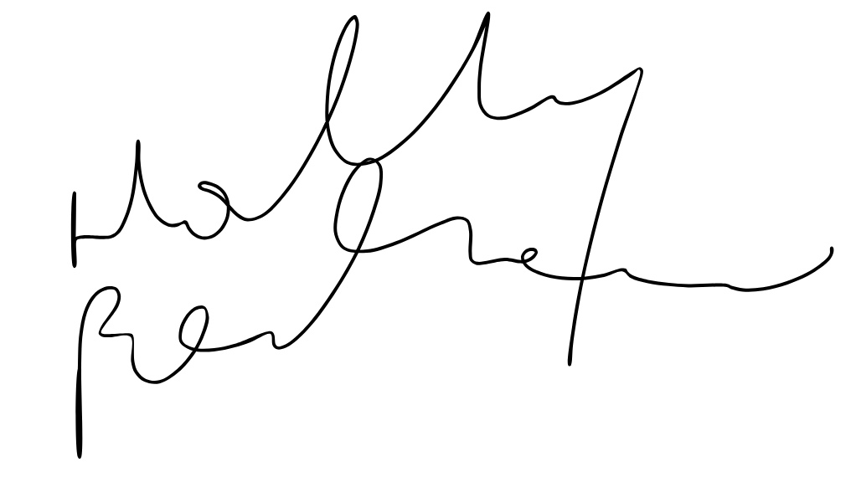

David Johnston

