RESIGNATION LETTER

From:
Casey Mayer
217 Lam Street Apt. 601
Joneston, CT 70060
1973-04-17

To:
Mary Robinson
471 Browning Via Suite 934
Dennisbury, NH 54701

RE: Resignation

Dear Mary Robinson,
Please accept this letter as my formal resignation from my position as Mid DevOps at Russell LLC, effective 10 weeks from today’s date, 1973-04-17.
I appreciate the opportunities for growth and development you have provided during my tenure. Thank you for your repeated guidance and support.
Please let me know how I can be of help during the transition period. I wish you and the company the very best going forward.

Sincerely,

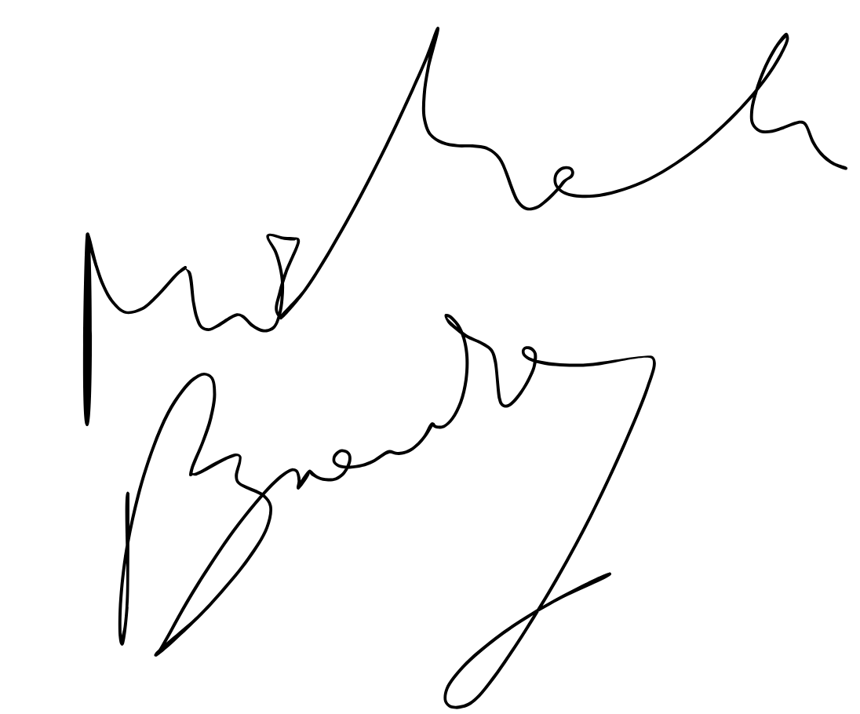

Casey Mayer

