IN THE CIRCUIT COURT OF THE [Judicial Circuit] JUDICIAL CIRCUIT, IN AND FOR [County] COUNTY, [State]
Case No.: 887222
Division: Family
9215 Murphy Viaduct Suite 299, South Robertchester, WV 08813
Court telephone No.: 001-534-743-5586
Husband: Cole Robinson and Wife: Morgan Carson

PETITION FOR SIMPLIFIED DISSOLUTION OF MARRIAGE
We, Cole Robinson, Husband, and Morgan Carson, Wife, being sworn, certify that the following information is true:
1. We are both asking the Court for a dissolution of our marriage.
2. Husband lives at 220 Sullivan Squares, Hansenmouth, CT 39093. Wife lives at 09680 Martin Meadow Apt. 622, South Brianshire, KY 38663.
3. We were married on December 03, 2015 in the city of North Kathleen, North Dakota.
4. Our marriage is irretrievably broken.
5. We do not have any minor or dependent children together, and the wife is not pregnant.
6. We have divided our assets and liabilities by agreement, and we are satisfied with the division.
[Check one only]
- ( ) Our marital settlement agreement is attached and was signed freely by both parties.
- ( ) We prefer to keep our financial agreements private.
Filed on: May 17, 2024
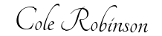
Husband's Signature: __________________________
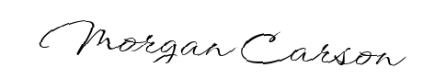
Wife's Signature: __________________________

