IN THE CIRCUIT COURT OF THE [Judicial Circuit] JUDICIAL CIRCUIT, IN AND FOR [County] COUNTY, [State]
Case No.: 549222
Division: Family
07670 Antonio Extension Apt. 470, Lake Logan, MN 63744
Court telephone No.: 6367565890
Husband: David Aguirre MD and Wife: Alexandra Hurley

PETITION FOR SIMPLIFIED DISSOLUTION OF MARRIAGE
We, David Aguirre MD, Husband, and Alexandra Hurley, Wife, being sworn, certify that the following information is true:
1. We are both asking the Court for a dissolution of our marriage.
2. Husband lives at 542 Brooks Viaduct Suite 028, Johnsonstad, VI 64658. Wife lives at 298 Elizabeth Mission Apt. 571, Joshuamouth, SC 78608.
3. We were married on December 13, 2019 in the city of Brownland, Colorado.
4. Our marriage is irretrievably broken.
5. We do not have any minor or dependent children together, and the wife is not pregnant.
6. We have divided our assets and liabilities by agreement, and we are satisfied with the division.
[Check one only]
- ( ) Our marital settlement agreement is attached and was signed freely by both parties.
- ( ) We prefer to keep our financial agreements private.
Filed on: April 23, 2024
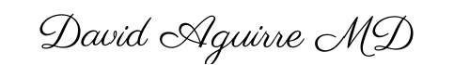
Husband's Signature: __________________________
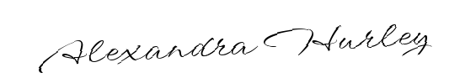
Wife's Signature: __________________________

